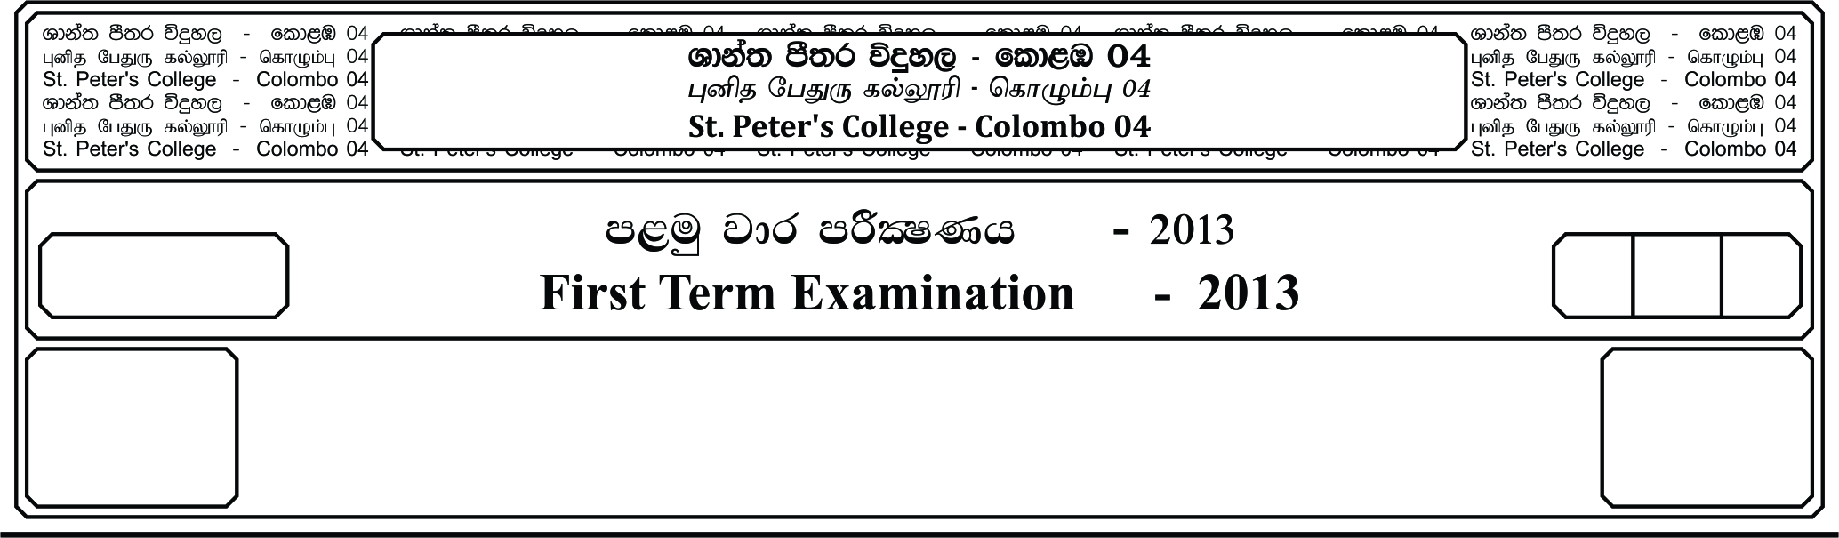

12 fY%aKsh

GRADE 12

E

meh 01

01 Hour

I

**fojk jdr mÍCIKh - 2022**

**Second Term Examination - 2022**

l%sia;shdks O¾uh - »

**CHRISTIANITY - I**

Answer all the given questions.

1. The literal meaning of the word “byblos” is,

i. Paper or scroll ii. Paper or word iii. Scroll or pen

iv. Biblon or Biblion v. Paper and book

2. The Holy Bible is the highest book, because it contains the,

i. Word of God ii. Byblos iii. Sacred Texts

iv. Biblia v. Gospel

3. AD comes from Latin word Anno, Domini and it’s meaning,

i. In the year of our Lord ii. In the presence of our Lord

iii. In the Divinity of our Lord iv. In coming of our Lord

v. In the years to come

4. The book of ___________ highly symbolic vision of the future rebellion judgment and consummation of all things.

i. Mark ii. Revelation iii. Luke

iv. Thessalonians v. Titus

5. The Septuagint or LXX from Latin Septuagint literally ___________ sometimes called the Greek Old Testament is the earliest Greek translation of the Old Testament from the Original Hebrew in 3rd BC.

i. Apocrypha ii. Seventy iii. Torah

iv. Fifth v. Septuagint

6. The first Hebrew text was written in ___________,

i. Consonants ii. Vowel iii. English

iv. Jew v. Latin

7. ___________ means text of the common people,

i. The vulgate ii. God to man iii. Bibilical text

iv. Jewish v. Psalms

8. The Greek word for revelation is ___________,

i. Divine ii. Septuagint iii. Apocalypse

iv. Knowledge v. Universal

9. ___________ is supernatural communication from God to man either oral or written – ect.

i. Revelation of peace ii. Revelation of sin

iii. Divine Revelation iv. Holy Spirit

v. Holy Trinity

10. The acts of God whereby He makes Himself and His truth known at specific times and to specific people by,

i. Patriarchs, Kings, Leaders and prophets etc.

ii. Human, Kings, authers and prophets etc.

iii. Kings, Queens and Jewish etc.

iv. God, Kings, Leaders and people etc.

v. Prophets, Kings, Mary and people etc.

11. ___________ is the Greek word used for Divine inspiration,

i. Theotokos ii. Theo iii. Theophilus

iv. Breath v. Theoko

12. The encyclical ___________ was written by,

i. Leo XIII ii. Leo V iii. John Paul IV

iv. Paul III v. Leo IV

13. The names that are used to introduce the nation that is connected with the chosen people,

i. Palestine, Canaan, Israel, Promiseland ii. Israel, Lydia, Egypt, Palestine

iii. Rome, Canaan, Israel, Promiselasnd iv. Promisland, Dubai, Israel, Canaan

v. Israel, Egypt, Palestine, Promiseland

14. Coastal areas, consist of three valleys,

i. Ahho valley, Sharon valley, Philistia valley

ii. Sharon valley, Bethany valley, Samaria valley

iii. Ahho valley, Samaria valley, Israel valley

iv. Samaria valley, Ahho valley, Bethany valley

v. Bethany valley, Ahho valley, Israel valley

15. Negeb means ___________ in the context of the Bible. It is meant as ___________

i. dry, south ii. South valley iii. Akko dry

iv. dry, light v. Dark, light

16. Around 1767 BC Egypt was conquered by ___________ who were considered to be the relatives of Abraham’s generation and belonged to sematic ethinicity.

i. Hiksos ii. Egypt iii. Nabi

iv. Babylon v. Israelites

17. The rule of Judges ended up in a failure to the following ___________,

i. They lived only in Judea ii. They worked hard to bring peace

iii. Life was too hard for them iv. They looked for money

v. There was no one common rule for the whole nation

18. King Saul was anointed by ___________ according to the order given by God,

i. Samuel ii. Solomon iii. Judah

iv. Zion v. Simeon

19. ___________the greatest king hailed in Judea after David and Solomon,

i. King Saul ii. King Josiah iii. King David

iv. King Joel v. King Jehoiakim

20. On the 25th of the month of Kislew, the feast of ___________ was ,

i. Jupiter ii. Sun iii. Moon

iv. Passoven v. Good Friday

21. The fifth governor of the areas of Judea, Indumaea and Samaria was ___________,

i. Pontius Pilate ii. Philip the Second iii. Archelaus

iv. Herod Antipas v. Solomon

22. Penateuch is “the first five books of the Bible.” It comprises,

i. Genesis , Luke , Mark , Exodus , Numbers

ii. Genesis , Exodus , Levitivus, Numbers and Deuteronomy

iii. Numbers , Deuteronomy , Revelation , Exodus , Genesis

iv. Deuteronomy , Mark , Revelation , Numbers , Luke

v. Exodus , Genesis , Luke , Numbers and Deuteronomy

23. ___________ tradition is competent in story-telling. Narrates incidents giving life to the charactors of the story.

i. J ii. E iii. D iv. P v. D and P

24. Abraham is also a prophet (Gen 20 : 7) Not only ___________ who has receive a prophetic vocation, but ___________ (Ex 15 : 20) are too prophets.

i. Abraham , Miriam ii. Miriam , Judith iii. Moses , Abraham

iv. Abraham , Sarah v. Moses , Miriam

25. According to D tradition ___________ brought national and religious reforms in the degraded empire of Judah during the reign of Manasseh.

i. King Solomon ii. Epiphanius iii. Herod

iv. Philip v. King Josiah

26. Having created man in His image and likeness. God gave man dominion over the creation and invited him to be the ___________ with God (Gen 1:27-28)

i. Equal ii. Co-creator iii. Angel

iv. Guide v. Kaden

27. The first book of the Holy Bible is the book of Genesis. It can be divided into 02 major sections.

i. Pre history – Gen 1 – 11 , Patriarchal era Gen 12 – 15

ii. Pre history – Num 1 – 15 , Patriarchal era Gen 1 – 2

iii. Patriarchal era Lev 1 – 8 , Pre history – Gen 1 – 2

iv. Pre history – Num 5 – 8 , Patriarchal era Num 2 – 7

v. Patriarchal era 2 – 7 , Pre history – 5 – 8

28. The process of creation has built into a systematic structure through this story. These are four common elements to each day. One of the 4elements.

i. The command of God “Let there be light.”

ii. Let not darkness be there.

iii. God’s light be own guide.

iv. The command is the will of God.

v. The will of God.

29. Jacob had a marvelous dream in ___________,

i. Bethelda ii. Bethel iii. Beersheba

iv. Bethany v. Bethlehem

30. Moses is a great ___________,

i. Philosopher ii. Artist iii. Creator

iv. Worker v. Prophet

***(2x30 = 60 Marks)***

**Part II**

* Answer **four** questions selecting **first question, which is compulsory.**

01. i. Name the 10 plagues. **(04 Marks)**

ii Write the Hebrew word for the unleavened bread **(02 Marks)**

iii. Name Basic Elements of the Passover Liturgy and there Implications. **(04 Marks)**

02. i. Explain the First Creation Story (Gen 1:1-2:4) **(05 Marks)**

ii. Flood and the Covernant with Noah’s story is a complication of the combination of both the J and P traditions. Explain **(05 Marks)**

03. i. Explain the message you receive from the story of the Tower of Babel. (Gen 11:1-9)

**(05 Marks)**

ii. Name two special promises, God gives to Abraham. **(05 Marks)**

04. i. Abraham’s faith journey begins with the chapter 12 of the book of Genesis. Considering the life example of Abraham how do you live a faith filled life – Explain. **(05 Marks)**

ii. What is your contribution to your society to lead life of faith amidst of all destruction that you face in day today living. **(05 Marks)**

05. i. Comparatively, there is a common plan for the 10 plagues. The ten plagues can be categorized into three. Explain **(05 Marks)**

ii. Write 10 Commandments. **(05 Marks)**

06. i. In the classification of the Prophets of Israel there are two types of prophets. Explain.

**(05 Marks)**

ii Explain the concept of Messianism. **(05 Marks)**